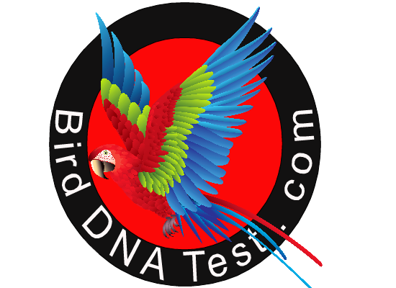BirdDNATest.com
Receipt / Account #___________________ Date________________________
Name: ______________________________________Business Name: ________________________________________
Address:___________________________________________________________________________________________________
City: _________________________________________ _______________________ ______________________________________
Country: ________________________________________________ Mobile # _______________________________________
Fax #_____________________________________ Email: __________________________________________________________

Comments_________________________________________________________________________________________________

 | Label ID # | Species of Bird | Bird ID | Sample type(feather /Blood)
1
2
3
4
5
6
7
8
9
10
11
12
13
14
15
16
17
18
19
20
21
22
23
24
25
26
27
28
29
30

Birds DNA Test Kuwait • www.Birddnatest.com•

Mobile: +965 69947441
Email: bird.dna.kw@gmail.com

